Test Case: tc002_SPX_Dev5_Crear_Requisicion_Spot_Tipo_Cobro_Project
Step 1 - Enter username and password and click to button Enter: Credentials Entered
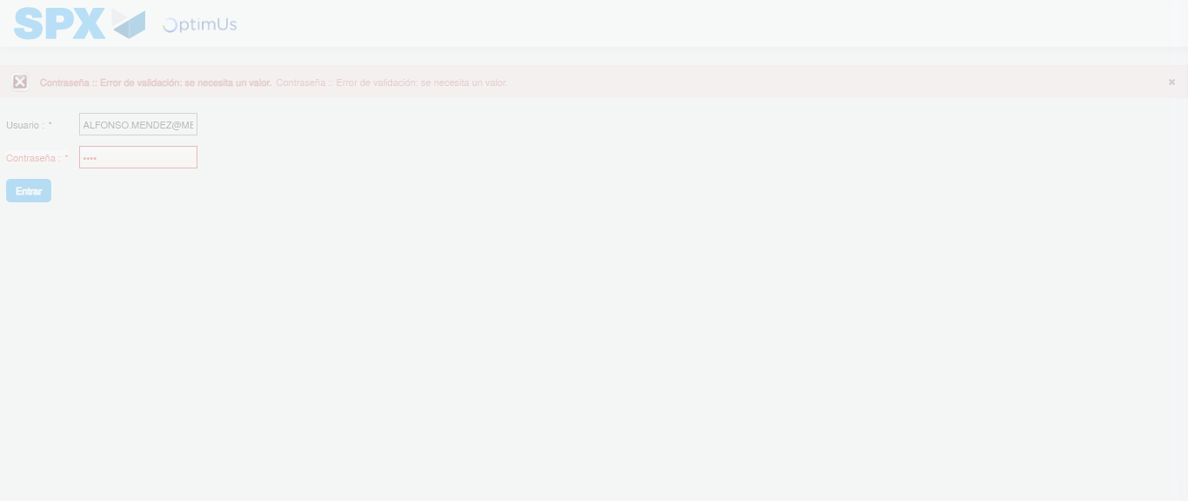Image file-name: QC_Testing-tc002_SPX_Dev5_Crear_Requisicion_Spot_Tipo_Cobro_Project-1783373949632

Step 2 - Select to UEN and Access to Spot Buy Requisitions : UEN Correctly selected and Correct access
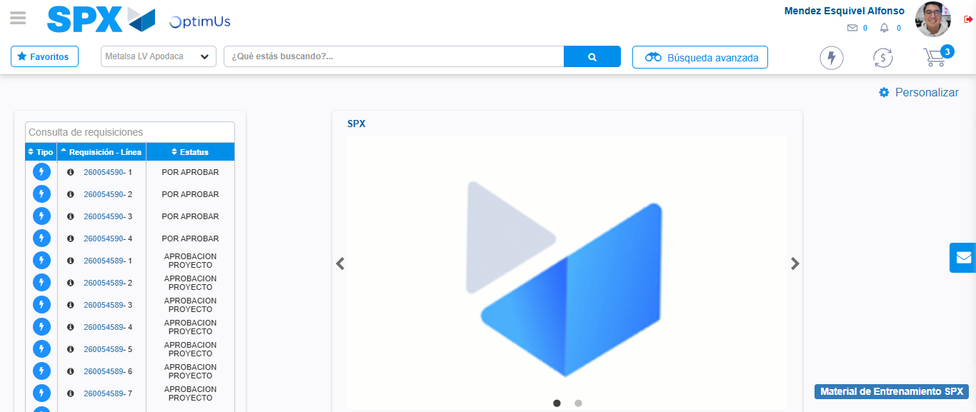Image file-name: QC_Testing-tc002_SPX_Dev5_Crear_Requisicion_Spot_Tipo_Cobro_Project-1783373974594

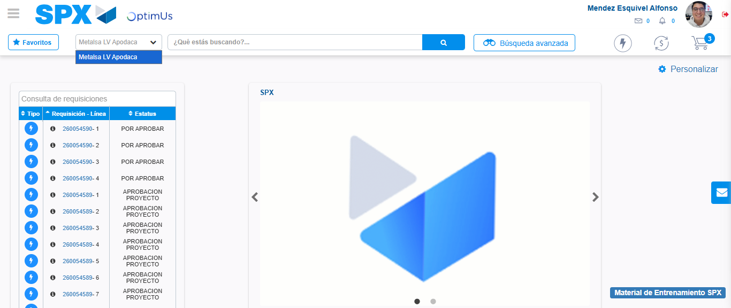Image file-name: QC_Testing-tc002_SPX_Dev5_Crear_Requisicion_Spot_Tipo_Cobro_Project-1783373977169

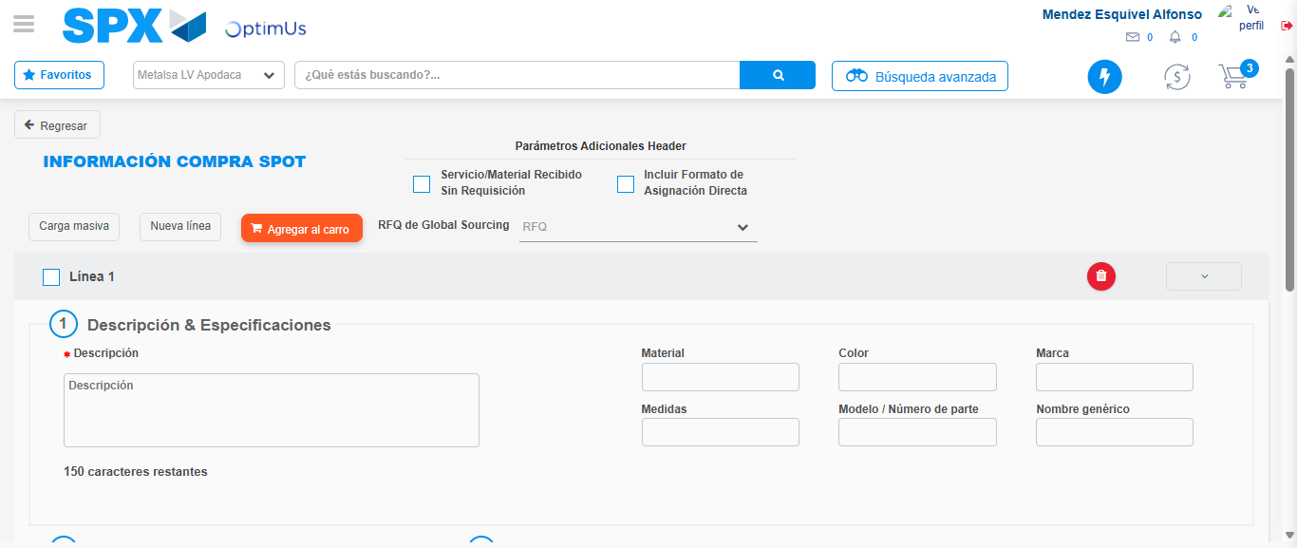Image file-name: QC_Testing-tc002_SPX_Dev5_Crear_Requisicion_Spot_Tipo_Cobro_Project-1783373995239

Step 3 - Data Capture Spot Buy Requisition: Data captured correctly
Image file-name: QC_Testing-tc002_SPX_Dev5_Crear_Requisicion_Spot_Tipo_Cobro_Project-1783373995504

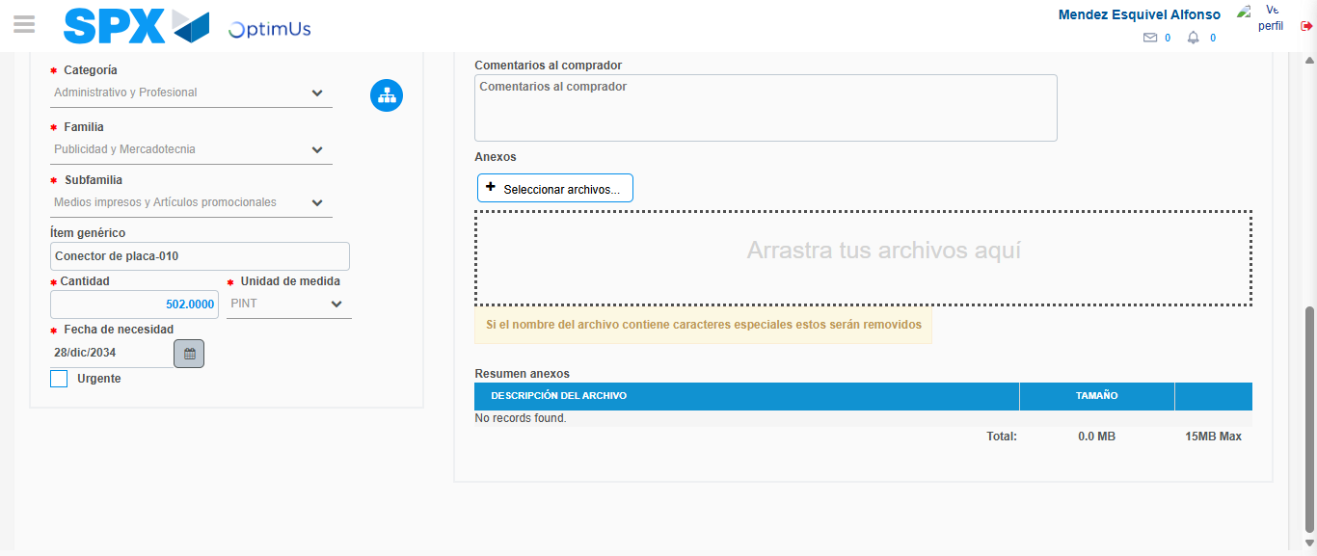Image file-name: QC_Testing-tc002_SPX_Dev5_Crear_Requisicion_Spot_Tipo_Cobro_Project-1783374006254

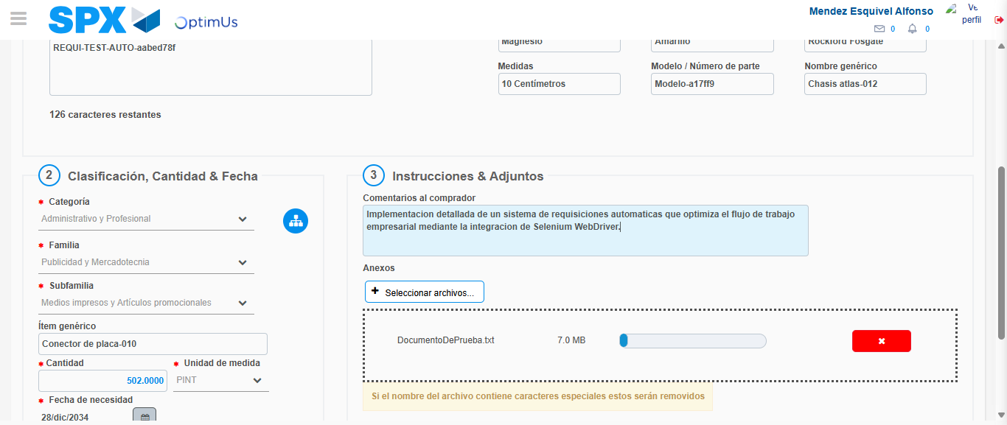Image file-name: QC_Testing-tc002_SPX_Dev5_Crear_Requisicion_Spot_Tipo_Cobro_Project-1783374007009

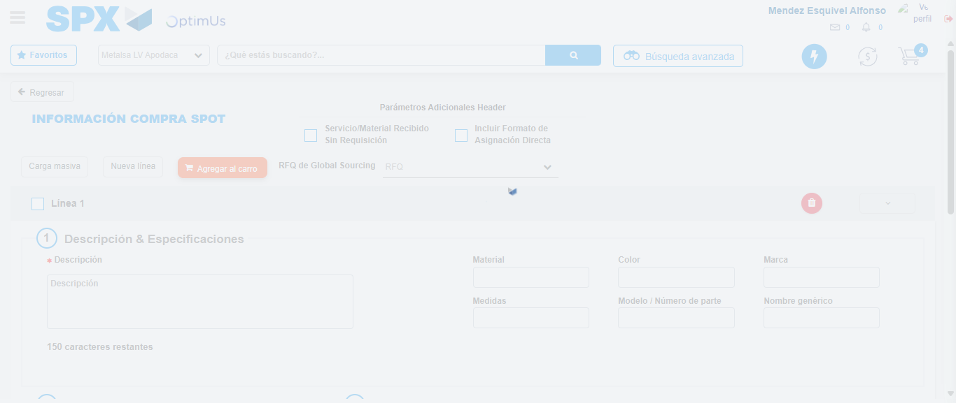Image file-name: QC_Testing-tc002_SPX_Dev5_Crear_Requisicion_Spot_Tipo_Cobro_Project-1783374008469

Step 7 - Return to Main Page SPX : Return to Main Page SPX
Image file-name: QC_Testing-tc002_SPX_Dev5_Crear_Requisicion_Spot_Tipo_Cobro_Project-1783373974594

Image file-name: QC_Testing-tc002_SPX_Dev5_Crear_Requisicion_Spot_Tipo_Cobro_Project-1783373977169

Image file-name: QC_Testing-tc002_SPX_Dev5_Crear_Requisicion_Spot_Tipo_Cobro_Project-1783373995239

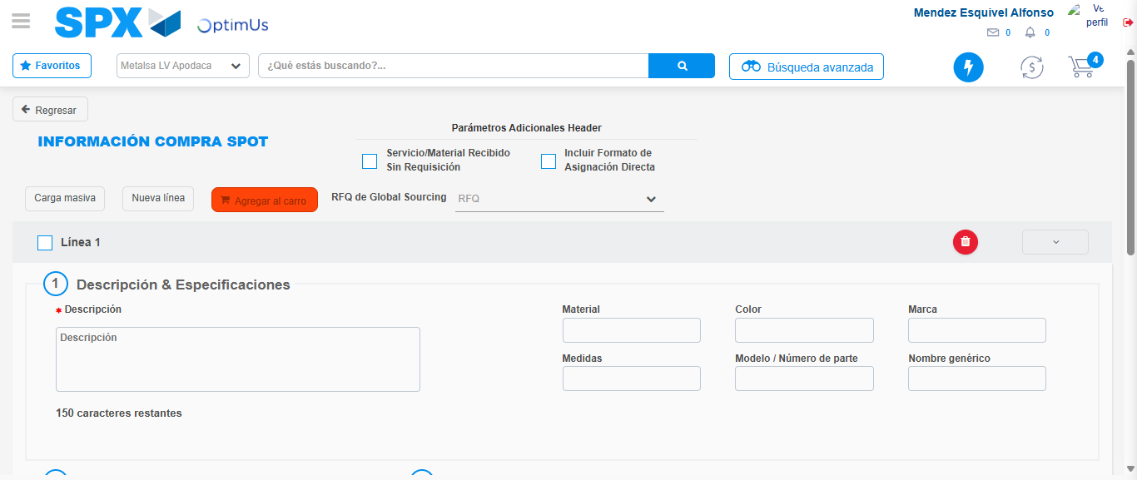Image file-name: QC_Testing-tc002_SPX_Dev5_Crear_Requisicion_Spot_Tipo_Cobro_Project-1783374010691

Image file-name: QC_Testing-tc002_SPX_Dev5_Crear_Requisicion_Spot_Tipo_Cobro_Project-1783374010875

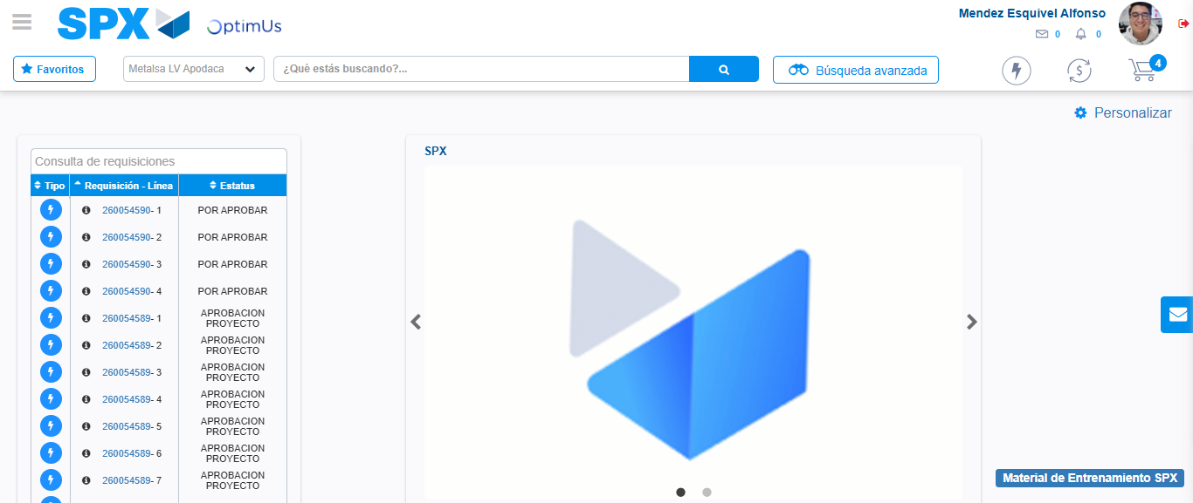Image file-name: QC_Testing-tc002_SPX_Dev5_Crear_Requisicion_Spot_Tipo_Cobro_Project-1783374031958

Step 8 - Log Out : Log Out SPX
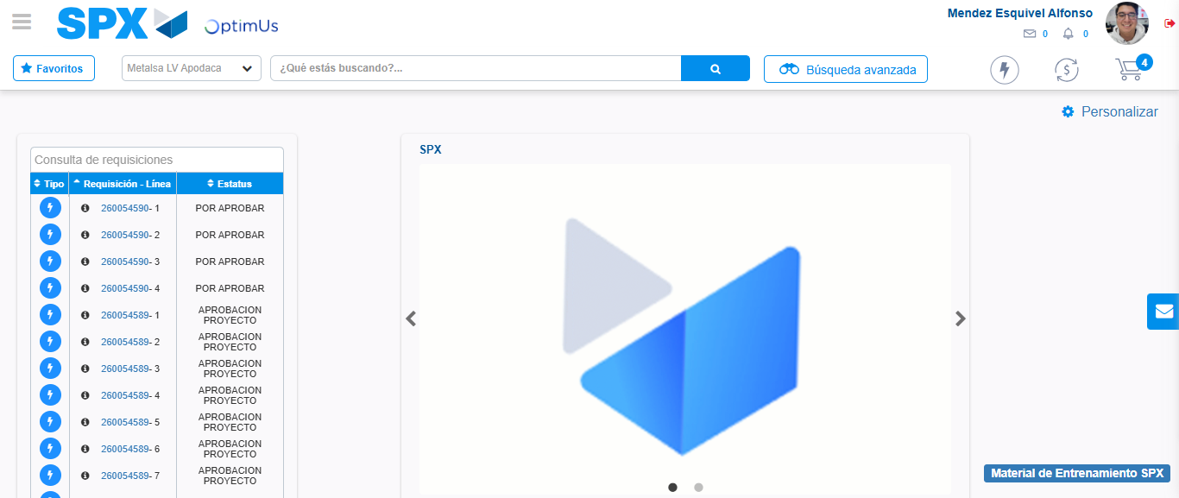Image file-name: QC_Testing-tc002_SPX_Dev5_Crear_Requisicion_Spot_Tipo_Cobro_Project-1783374032199

